ASSIGNMENT # 2 Max. Points: 10
Issue date: 14-Jun-2021 Submission Date:17-Jun-2021

- Write a program that: (04 Pints)
- Creates int, str, double and float variables
- Convert int -> str
- Convert int -> double
- Convert int -> float
- Create a dictionary list

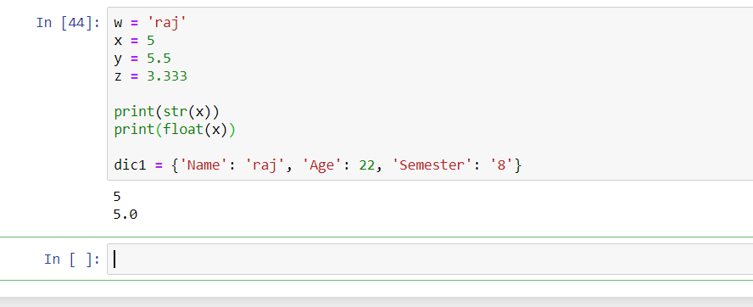
- Is there a solution for Tuples immutability – what if I want to change data (replace 5 with 15) of this Tuple: (03 Pints)
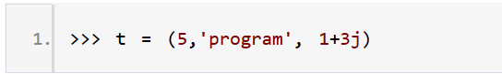
Tuples are unchangeable, or immutable. But there is a workaround.
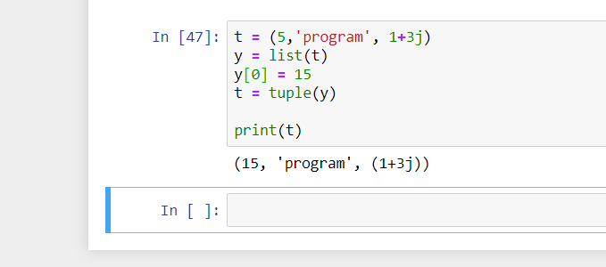
- Write a python program to create a dictionary where the keys are 1 to 5 (key = 1, 2, 3, 4, 5), and the respective value for each key is value = key² (03 Pints)

dict1 = {1:1, 2:4, 3:9, 4:16, 5:25}

